1. Please read MINI-CASE: Time Hayden's Last Vacation on page 154 - 155 of the textbook and discuss for following questions:

- People talk about entrepreneurs depending on luck. Tim only saw Terry Leobel that one time. Their conversation was one of the factors leading Tim to decide to go full-time, starting his business as “Vivid Sky” with the initial product, “SkyBOX”. Was it luck on Tim’s part? Was there anything Tim could have done to improve his luck?

- Tim had concentrated on mastering the business and technology angles of the SkyBOX, but was slightly taken aback when asked about how his personal life would change if he went into entrepreneurship full-time. If you were contemplating a full-time entrepreneurial career, what are some of the personal considerations you think might be important?

- Why would Tim’s employer’s plan to change business directions make becoming a full-time entrepreneur more attractive?

- Tim felt he needed to go full time to take the SkyBOX “to the next level.” Can you think of ways he could have continued building up the SkyBOX while sticking with a part-time approach? What would have been the downfalls?
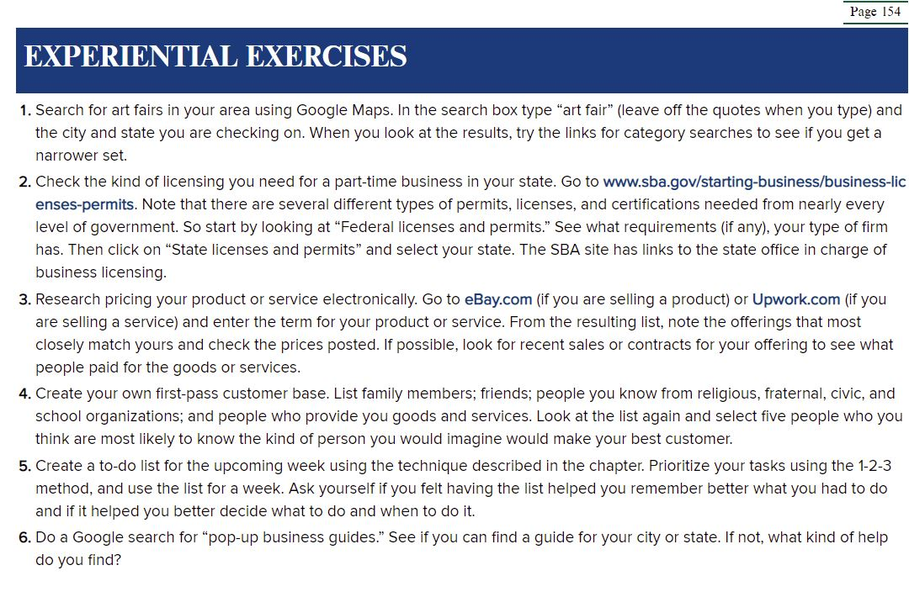

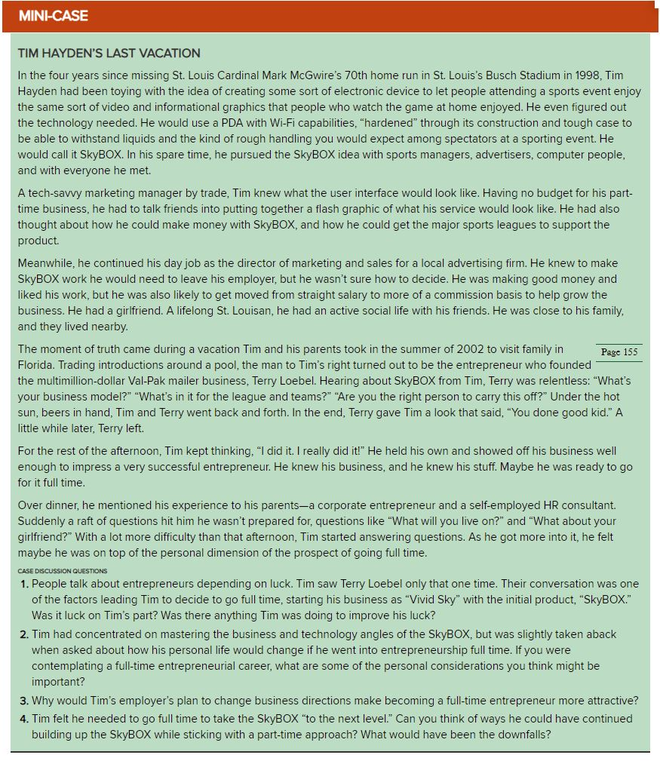

2. Please read: Focus on Small Business: Joe Fisher, Zoë Scharf, and the Strategy behind Greetabl on page 193 – 194 of the textbook and discuss the following questions:

- Did Joe start with the idea for his business or with the goal of starting a business?
- What was the role of the IBISWorld industry analysis in the creation of Greetabl?
- What kind of strategy did Joe and Zoë plan for Greetabl?

